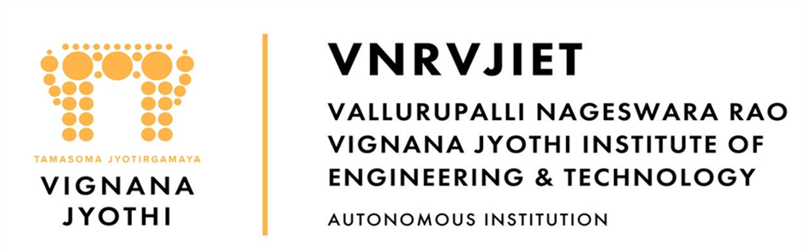

Mentoring, Training & Placements Department
Daily Report 25-03-2026
Description |  | Total to be received | Received till Date | Received Date | To be received

II | Staff Attendance
S.No | Dept. | Category | On Rolls | Absent | DQI | DQI Performance | Overall DQI | Overall Performance
1 | MTP |  | 8 | 0

 | III. Students’ Attendance:
IV | MTP:  SAMUEL  - Infosys HackWithInfy has given another Mock Test today. Window time – 2 PM to 7 PM. Informed all the pending students to attempt the same.  - JPMC coding test - 2nd year students who registered internship hiring received mails. 450 have confirmed that they have received test link. Coordinating with students to ensure they take test on time. Deadline - end of 26th March.  - DBS - Database of 3rd year CSE, IT, AILM, AI&DS has been shared with HR team for the internship hiring process. DBS is planning an online test on 26th and 27th March. Informed the students to prepare well.  - Kumaran Systems - Revised Databased of 200 students has been shared with HR team. Drive is scheduled on 31st March  KABITA  - Incedo: On-campus drive scheduled on 26th March. All necessary arrangements done & information shared with all shortlisted students.  - NextGen: Opportunity for batch 2027 AIML students Stipend: 25 K CTC: 7 to 8 LPA. Registration students completed registration & data shared for further process.  - DTCC: 14 shortlisted students’ interview completed at DTCC office today. Result awaiting  POONAM  - Calfus Technologies India Pvt. Ltd is hiring updates for B.Tech 2027 Batch- 11 students who registered for the Oracle Fusion Technical Intern role* HR team is proceeding with hiring for this position. In connection with this, the test link has been sent to the students registered email IDs and all 11 students are required to complete the test by tomorrow, 12 PM. Further shortlists will go to communication and Technical and HR round.  - Berger Paints: Total of 6 final selected students have been communicated by HR, and the format to fill in the student details has been shared. The same format, along with the completed details, has also been shared with the HR team for their reference.  - India Space LAB – Summer Internship: The details for the 2026 batch have been shared with all students in the group.  - Dr. K V M Achuta Ramaiah and Dr. K V Ramana conducted a training and orientation session at P-418 from 2 – 4 PM attended by 8 shortlisted students (2026batch) in view of the Incedo campus drive scheduled tomorrow.  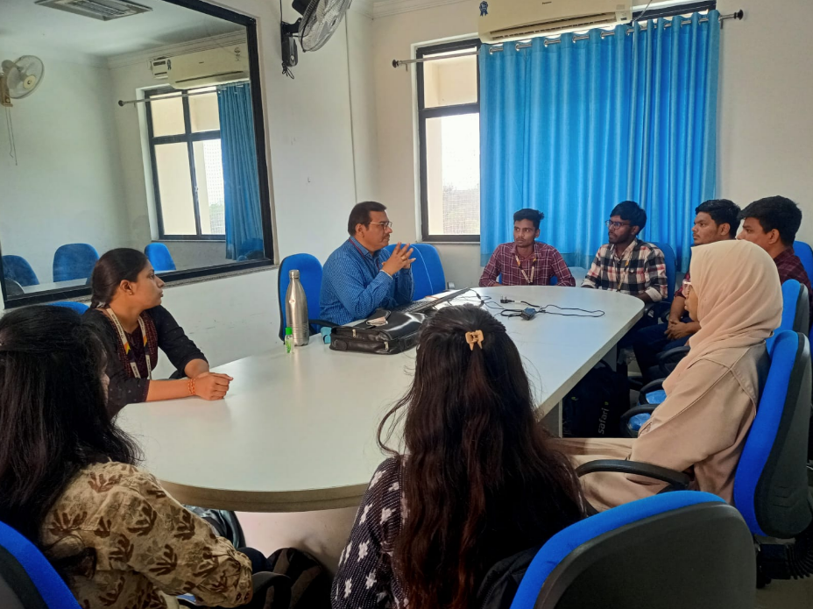 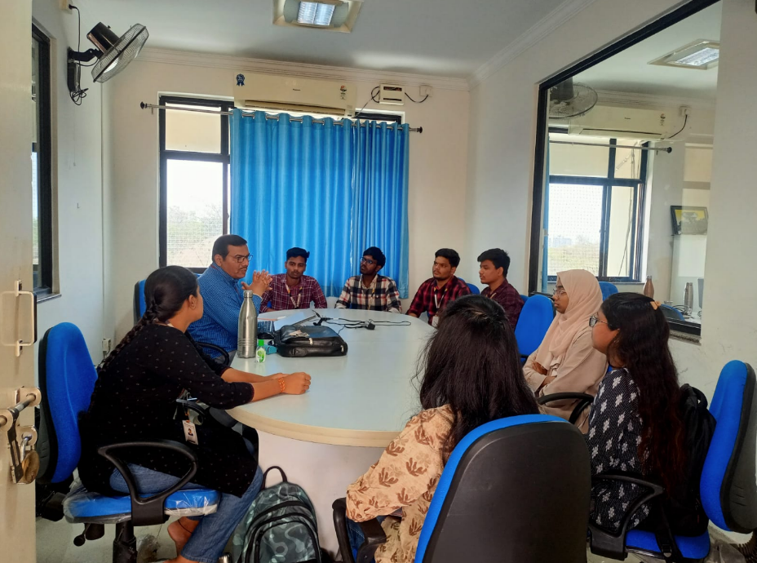  - The Training & Placements Department organized a Technical Training Session in association with Talent Shine Pvt Limited on Advanced Data Structures on 24th March 2026, from 7:00 PM to 9:00 PM. The session was be conducted in online mode for B.Tech 3rd Year 2nd Semester students of CSE, IT, and Allied branches.  - This program was organized in view of the upcoming Infosys – HackWithInfy Assessment scheduled on 28th March 2026, to help students strengthen their problem-solving skills and technical knowledge.  - The training covered key topics including Binary Search Trees (BST), Graphs, and Dynamic Programming.  - The meeting link for the session was shared at 6:00 PM, all eligible students attended the session.  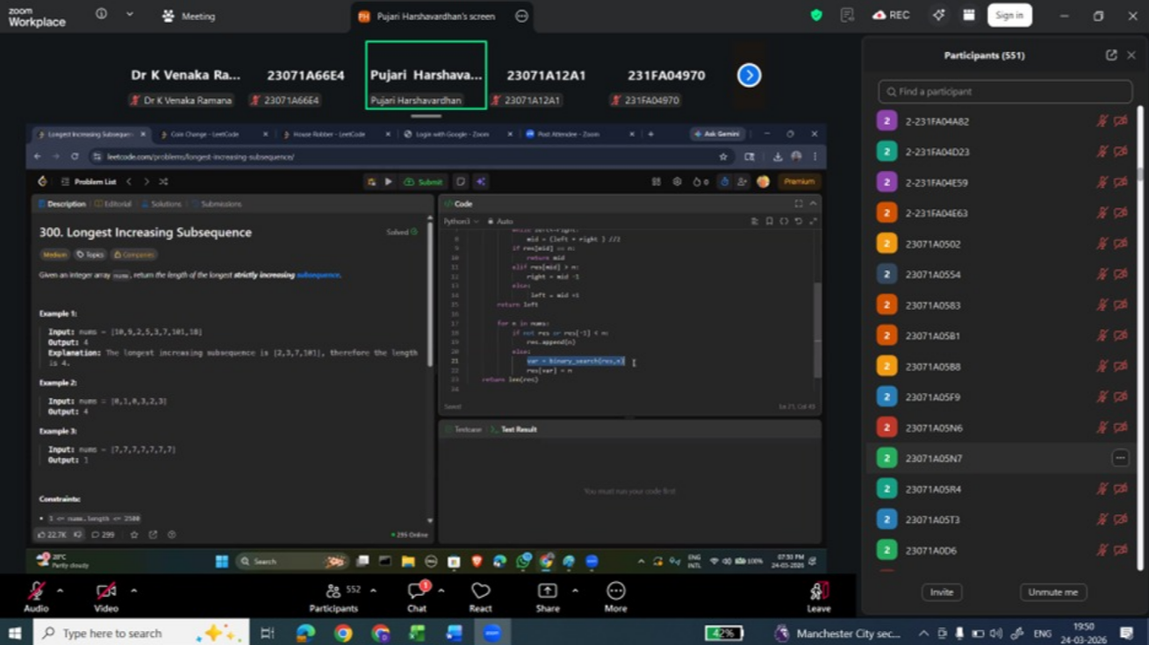 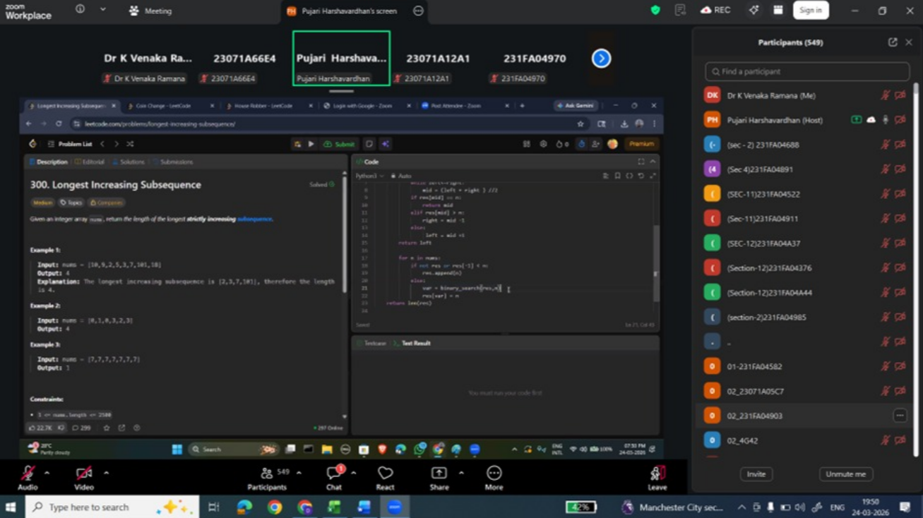  V HOD-CSE (CSDS&AIDS):  VI HOD-IT:  VII HOD-ECE:  2025 2026 Batch Plis open Summary:  CSE CSBS AIML IOT DS CyS AIDS IT ECE EEE EIE ME CE AE M.TECH TOTAL  359 65 276 85 187 63 65 249 207 83 92 57 62 19 18 1887  2025
VIII Classwork Adjustment / Lectures Interchanged:
S. No. | Dept | Subject | Adjusted from | Adjusted to

IX. Participation by Staff/Students:
S.No | Name | Event | Status (delegate /paper)resent, speaker) | Date and  Duration

X | Particulars of Library Services or Transactions: | No.s

For Head of the Department.

